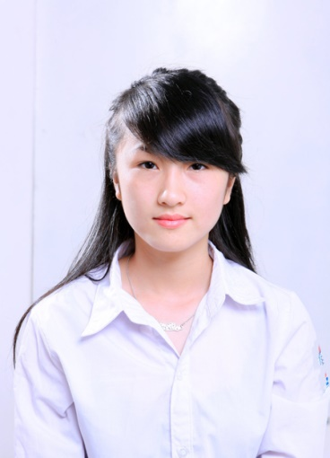
CURRICULUM VITAE

PERSONAL DETAILS
Name in full: PHAM THUY TRANG
Date of birth: December 12th 1991
Gender: Female
Family Status: Married
Resident: No.401, Pham Van Dong Street, Cau Giay District, Hanoi
Telephone: (+84) (0) 912345678
E-mail address: phamthuytrang@gmail.com

EDUCATION
University: Hanoi Open University
Time: 2009 - 2014
Major: Faculty of English and Modern Languages

EXPERIENCE

4/2011 -1/2012: Receptionist at Fitness Centre at Hanoi Daewoo Hotel (9months)
2/2012 – 3/2013: Receptionists at Mai Charming hotel - 29 Hang Bong (13 months)

Job Descriptions:
- Meeting and greeting clients
- Booking meetings
- Arranging couriers
- Keeping the reception area tidy
- Answering and forwarding phone calls
- Screening phone calls
- Sorting and distributing post
- Direct recommend tours and travel services to foreign tourists: hotels, tours, flight tickets, visa services, car & boat rental ...
Key achievements:
- Confident in communicate with foreigners
- Confident in selling travel services directly
- Experience in persuade different kinds of tourists
- Experience in dealing the troubles
- Great chances to learn more about foreign culture
- Improving English speaking skill as well as communication skill
5/2013 - 2017: Receptionist(8months) Front Office Supervisor(12months), Assistant of Front Office Manager(10months), Front Office Manager(12months) at Medallion Hanoi Boutique Hotel 11 Ma May
Job Descriptions:
- Respond to guests needs and anticipate their unstated ones
- Expect and react promptly to guests’ requirements and inquires, actively listen and resolve guests’ complaints, issues, problems in a quick, efficient manner to maintain a high level of customer satisfaction and quality service.
- Oversee and coordinate all arrivals and departures of special guests (VIPs, SAs etc)
- Coordinate and manage communication between guests and staff and follow up to ensure complete service recovery
- Promote all amenities, conveniences and programs offered
- Appraise team’s performance and produce reports
- Examine activities logbook, assign tasks appropriately and implement control schedule
- Ensure Outstanding customer care at all times.
- Maintains a friendly, cheerful and courteous demeanor at all times.
- Courteously and accurately answers inquiries from potential guests and accepts hotel reservations.
- Responds to telephone and in-person inquiries regarding reservations, hotel information and guest concerns.
- Uses suggestive selling techniques to sell room nights, increase occupancy and revenue.
- Supervise daily shift process ensuring all team members adhere to standard operating procedures.
- Train, direct the work of resolve issues/problems and coach and counsel the front desk team members to ensure a quality operation.
- Allocate rooms to expected arrivals after checking the guests preferences and special requests.
- Build strong relationships and liaise with all other department's especially housekeeping, reservations etc.
- Operates the equipment, including, assisting incoming & outgoing calls, setting wake-up calls, enabling DND (Do Not Disturb)
- Cross Check all billing instructions are correctly updated
- Controls cash transactions at the front desk and maintains complete responsibility for personal bank as specified by hotel bank agreement policy.
- Supervise the operations of the front desk to ensure an optimal level of service and hospitality is provided to the guests.
- Being trained and provide working equipment & document
- Research, built-up and maintain partnership
- Take care partners’ request, bookings and payment

Key achievements:
- Gain lots of relationship in work
- Know more about what exactly be
- Improving English writing skill
- Knowledge of travel destinations
- Experience in Halong tours
- Experience in training a new staff
- Knowledge more about the specific side of tourism and hotel industry
- Knowledge of almost tourist sites in Vietnam Northern, even the non-touristy & off-beaten destinations
- Ability of communication, team-work, building tour program, using social network for marketing & sales, taking care of tourists
SKILLS
- Teamwork skill and independent problem-solving skill
- Languages: Vietnamese (Native speaker), English (fluent)
- Computer: MS Word, MS Excel, Power Point, Internet, social media
- Business Communication: both personal and interpersonal, Presentation, Emails, Debate skill
- Research skill
- Time management skill and organization skill

PERSONAL HOBBIES
- Traveling, exploring new things
- Making friends and discovering strangers (especially foreign companions)
- Searching the web
- Movie & Music
- Reading

PERSONAL CHARACTERISTICS
- Positive, active, energetic, humorous and open
- Responsible, enthusiastic, careful and calm
- Polite, patient and caring
- Quickly adaptable and organizational (time and money management)
- Credible, fair
- Self-confident, motivated, ambitious

REFERENCE
Mr. John
General Manager – 0123456789 – john@abc.com
I assure that the information provided is true and correct.

